Design Document Part 3

Project Management:

The project management style we have chosen is agile. A major reason for this is because as we have learned more about our client’s wants and needs from the project, our requirements and design choices have changed. An agile management style also allows us to focus on short term sprint goals that will allow us to better stay on track for finishing the project on time. A downside to this is that we don’t have many hard deadlines which could allow us to become distracted and put too much focus on an area that doesn’t require it.

Task Decomposition:

We have broken our project into four main tasks that we need to complete. Those tasks are: Pull power from a standard wall outlet, test board accuracy by simulating an RTD using a voltage, test the fault conditions of the board such as open and short circuit conditions, and finally output the results on a GUI. An image of our task decomposition is shown below in figure 1.

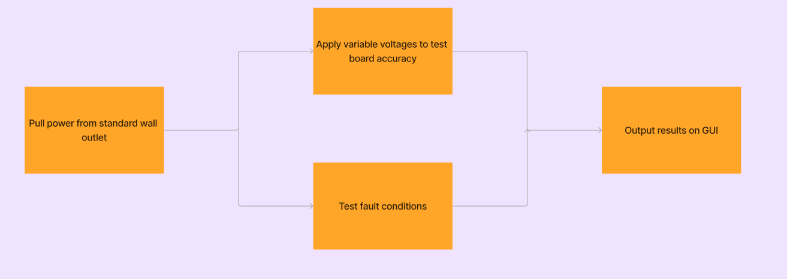

*Figure 1: Task decomposition*

Project Milestones:

* Design a power supply for our test device
  + Our device must be able to use a standard wall outlet as a power source
* Effectively communicate with Sukup device
  + Our microprocessor will need to communicate with the Sukup board using the Modbus 485 protocol
* Produce accurate voltage to simulate RTD resistance
  + Using a DAC produce accurate voltages to meet resolution requirements defined by the client
* Simulate/detect fault conditions
  + Force fault conditions to be met on Sukup’s device to ensure the correct error is read by Sukup microprocessor.
* Display results
  + Display results of all tests on LCD screen GUI
  + Send results to connected computer

Project Timeline:

Our project timeline is currently a bit flexible as discussed with our advisor. We however did want to break the project down into phases where we can look at our project's progression. We can break it down into three distinct phases which all can have subcomponents. We begin with researching and understanding the board that was given to us by Sukup. This phase will take the majority of our first semester as it is critical in constructing a PCB that meets all the requirements set for us. We start by looking at the schematics and code shared so we can fully understand the data we are testing.   
  
From there we move onto designing our own PCB that we hope to have done by the end of the semester. This phase includes schematic creation, peer reviews, revisions, and PCB layout. For each of these steps our team will meet with our advisor to make sure that our board is constructed properly and ready for fabrication. Once the board is fabricated we can focus the majority of next semester on testing and revisions. This will help give us plenty of time to test our board against the Sukup board as well as make any revisions to the schematics based on our clients response.

Risks/Mitigation:

There can be a few risks seen when creating a PCB such as delays in fabrication. Each fabricator has a different fabrication time that we will be waiting on during our semester. We hope to help mitigate this by using this time to code on a microcontroller that will be the same as the one on our PCB. We will also mitigate this by having our design finished by the semester so that fabrication can take place over the summer if necessary. Overall the biggest risk to our project is time as there will be periods where we will not have control over how fast our board is being produced.

Personnel Effort Requirements:

This project will require a significant amount of effort from all members of the group. When creating any PCB design it requires various people taking a look and making comments on schematic choices. By having peer reviews we can answer questions and have a collaborative effort on our design choices. There is plenty of new learning and skills to be developed as all members of our group are EE majors with not much coding experience. There is a significant portion of the project that will require us to learn and develop in python.

Other Resource Requirements:

Other resources we will need to complete this project are:

* Power converter (120 VAC to 24 VDC)
* Voltage regulator (24 VDC to 5 VDC, 5 VDC to 3.3 VDC)
* Microcontroller
* LCD display
* Digital to analog converter
* RS485 to USB converter